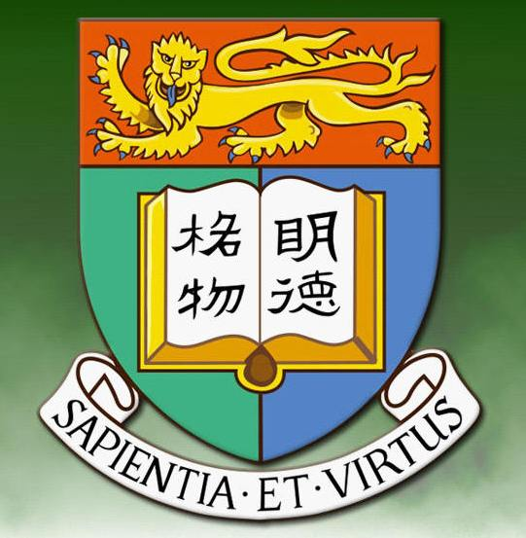
2009 Fall Gathering Report

By Sau-Fong Siu

Professor Siu Yum Tong 蕭蔭堂and his wife Professor Wong Sau Fong 黃秀芳 have been serving as the conveners for the HKU Alumni Network of New England since its inception in 2005. The Network’s directory now lists 60 alumni. The annual dinner gathering was held in Chau Chow City Seafood Restaurant in Boston Chinatown on November 7, 2009. With 45 adults and 3 children present, it was the best attended event thus far for the Network. We were particularly glad to see all eight undergraduate exchange students -- six studying at Tufts University and two at Mount Holyoke College-- and their mentors. Yum Tong started the evening with a slideshow of the membership profile and major events in the past. Sau Fong noted the rather dramatic increase of young graduates from the 2000s. They have now outnumbered the 1960s graduates, which used to constitute the largest group. The number of Putonghua speaking alumni has also increased, as has the number of alumni holding graduate degrees from HKU. Before dinner was served, attendees were treated to a virtual tour of HKU’s Centennial Campus. Everyone was impressed by the bold vision behind the project. As usual the gathering ended with the lucky draw of prizes donated by our alma mater’s Development and Alumni Affairs Office. Joshua Lo, son of alumni Victor Lo 老瑞欣 and Florence Yong 楊曉玲, and Jerry Liang, son of alum Liang Jianglin 梁江林, assisted in the drawing of numbers.

